**Name: Jesnamol Thomas**

**Roll No: 6**

**Batch: B**

**Date: 21/04/22**

**NETWORKING & SYSTEM ADMINISTRATION LAB**

**Experiment No.: 2**

**Aim**

Familiarization of linux command.

**Procedure**

**1. read variablename :** used to read the contents of a line into a variable**.**

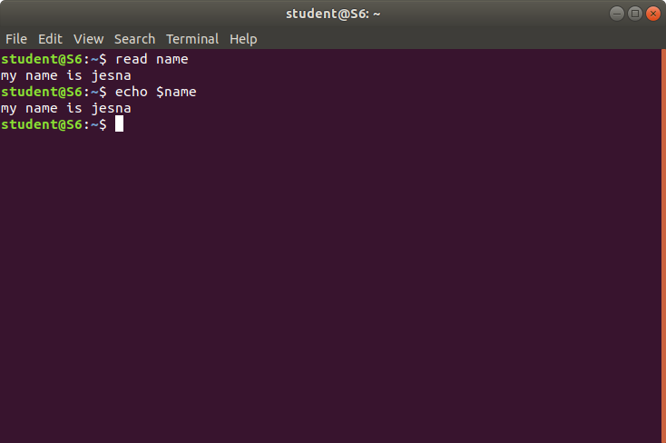

**2.locate filename:** Used to find the files by name.

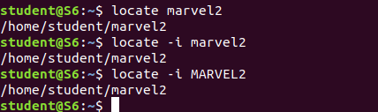

3.**locate -i filename:** Used case insensitive finding of files.



4.**find filename:** Used to find the files that present in the directory by name.



**5.grep word filename:U**sed to search for a string of characters in a specified file.

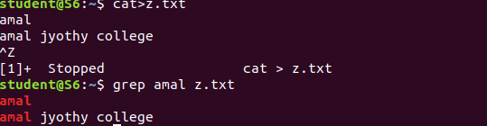

**6.grep -i word filename:U**sed to case insensitive search for a string of characters in a specified file.

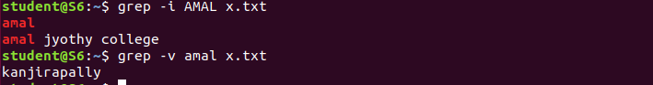

**7.grep -v word filename:**Used to inverted search for a string of characters in a specified file.The lines which does not contain the word.



**8.grep -A1 word filename:**Used to read the lines after the word.



**8.grep -B1 word filename:**Used to read the lines present before the word.

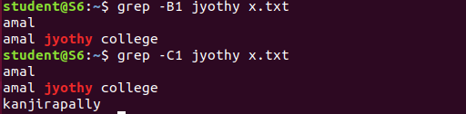

9. **grep -C1 word filename:**Used to read the lines present before and after the word.



**10.df:U**sed to show the amount of free disk space available on Linux.

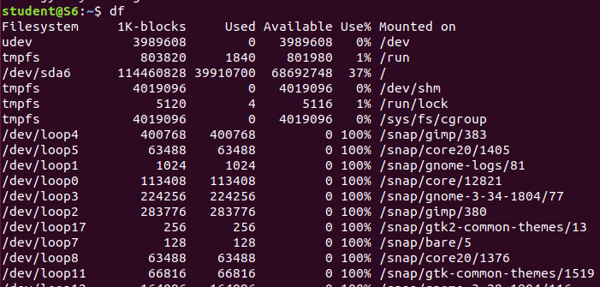

**11.df -**m:Displays the amount of disk space in megabytes available on the file system.

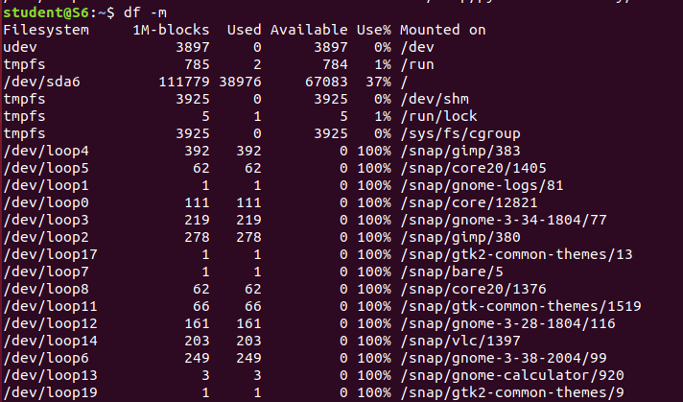

**12.du:** Displays the amount of disk space used by directories.

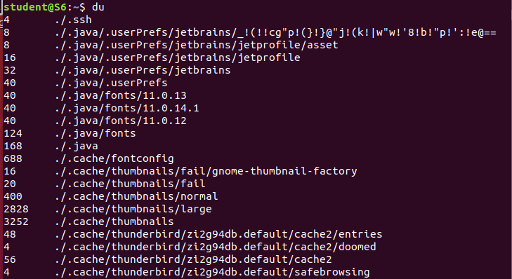

**13.wc -l filename:U**sed to find out number of lines in the files

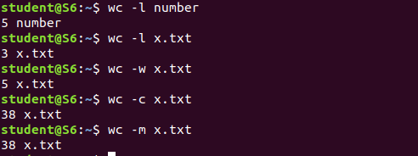

**14.wc -w:**used to find out word count in the file.



**15.wc -c:**Used to find out number of characters in the files.



**16.wc -m:**Used to find the number of bytes in the files .

